Promoting Understanding and Retention of Material:
Adult Learning Theory Comes Alive!

Activity #1: Best and Upcoming Learning Events
2 minutes

- Consider the best teaching or learning event you can remember participating in…
What made this a great learning event?
- What is an upcoming learning event you are supposed to teach?
Share your thoughts with a partner (Think-Pair-Share)
We will hear a sample

Activity #2: Explore the AIM to ACT Toolbox
5 minutes

Work in small groups
Pick a topic your are scheduled to teach
Select 1-2 techniques from the Aim to ACT Toolbox
Incorporate them into your didactic plan
Be prepared to share your plan

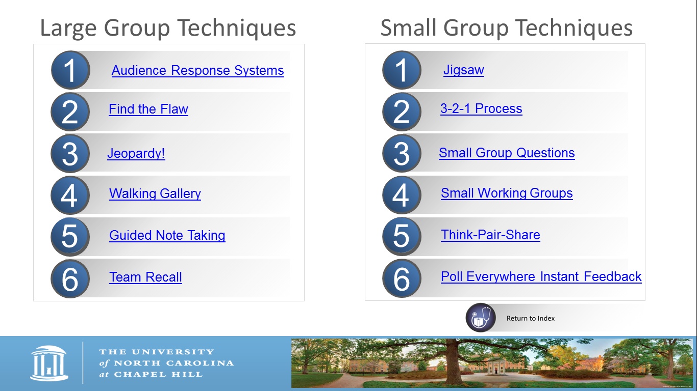

Activity 3: Planning This Learning Event Using the 8 Steps (Input)

Example of Our 8 Steps

- Who: 60 family physicians from various residencies across the country.
- Why: To provide the opportunity to learn the 8 Steps and 4 A’s and practice developing learning tasks for CME lectures to learners, students, residents and faculty.
- So that:
Learning: Did the participants learn the 8 Steps and 4 A’s, design learning tasks, and reframe their educational philosophy?
Transfer: Did the participants give their educational session using the 8 Steps and 4 A’s prepared during this workshop? Future learning event?
Impact: Have they continued to use this educational philosophy to prepare for and execute other educational sessions? Are they teaching others the same concepts?
- When: 4 April 2016; 1430-1530; late afternoon on a Monday.
- Where: Hotel Conference Room, must bring handouts, laptop, clicker and speakers.
- What:
  - Knowledge: the 8 Steps, 4 A’s from Jane Vella’s, On Teaching and Learning.
  - Skills: Design learning tasks.
  - Attitudes: Reframe previous educational philosophy to incorporate Vella’s system and learning tasks.
- What for: achievement based objectives.
By the end of our session together, we will have:
- Learned one planning system.
- Identified the four types of learning tasks and examples of each.
- Designed four learning tasks for an implementation activity as well as for a planned educational event with one example from each of the 4 A’s.
- Shared planned educational event and learning tasks with one individual or the group.
- How (4 A’s):
Timeline: 50 minutes total
Anchor Activities: 5 minutes
Add Activities: 20 minutes
Apply Activities: 20 minutes
Away Activities: 5 minutes

Using my example as a template, complete the 8 Steps for a learning event you will do.
Activity 4: Planning Your Learning Event Using the 8 Steps (Implementation)

Don’t work on the 4 A’s yet!
When you are finished, share your ideas with 2-3 people around you.
Take 10 minutes.

Your Learning Event Topic: ____________________________________________________

Your 8 Steps
- Who: ____________________________________________________________________
- Why: ____________________________________________________________________
- So that (the ultimate change to be seen):
Learning: what occurs within the event_____________________________________ ?
Transfer: taking learning to new place _____________________________________ ?
Impact: change in organization/system _____________________________________?
- When: ___________________________________________________________________
- Where: __________________________________________________________________
- What: ___________________________________________________________________
- Knowledge: ________________________________________________________
- Skills: _____________________________________________________________
- Attitudes: __________________________________________________________

- What for: Achievement based objectives
By the end of our session together, we will have:
- _________________________________________________
Objectives should be:
- Specific
- Measurable
- Expressed as a verb
- _________________________________________________
- _________________________________________________
- _________________________________________________

- How (4 A’s):
Timeline – Amount of Time: _____________________________

Activity 5: Planning These Learning Activities Using the 4 A’s (Add)

Example of my 4 A’s
7. How (4 A’s)
Anchor Activity (5 minutes) – intro, quote, objectives using PowerPoint.
Add Activity 1 (10 minutes) - Example 8 steps and timeline using worksheet and PowerPoint.
Apply Activity 2 (10 minutes) – Participants fill in 8 steps for an upcoming educational event.
Anchor/Add Activity 3 (5 minutes) – Example 4 A’s using worksheet and PowerPoint.
Apply Activity (5 minutes) – Participants develop 4 tasks using each of 4 A’s for a 4 year old to learn how to make PB&J sandwich.
Add Activity (5 minutes) – Watch PB&J video.
Apply Activity (20 minutes) – Participants collaborate and develop 4 tasks using 4 A’s, principles and techniques for an upcoming educational event.
Away Activity (5 minutes) – Participants share their event with 1 colleague and then give the event.
Anchor: connect with what they know
Add: learn something new
Apply: practice what they learned
Away: take it home and use it

Activity 6: How to Make a PB&J Sandwich Using the 4 I’s (Implementation)

Develop 4 learning tasks to teach a 4 year old how to make a Peanut Butter and Jelly sandwich.

Learning Event: How to make a Peanut Butter and Jelly Sandwich for a 4 year old

Learning Task 1 (Anchor Task): _________________________________________________

Learning Task 2 (Add Task):_____________________________________________________

Learning Task 3 (Apply Task):____________________________________________________

Learning Task 4 (Away Task):____________________________________________________

Design one learning activity for each of the 4 A’s (Anchor, Add, Apply, Away) for your educational event. Consider active learning techniques you have used or experienced.
Activity 7: Planning Your Learning Activities Using the 4 A’s (Apply)

Work in any size group.
Work preferably with colleagues with whom you will interact outside of this workshop.
Feel free to move around.
I will circulate to help as needed.

Learning Activity 1 (Anchor Task): ______________________________________________

Learning Task 2 (Add Task):____________________________________________________

Learning Task 3 (Apply Task):____________________________________________

Learning Task 4 (Away Task): _______________________________________________

Activity 8: Give Your Learning Event (Away)

Find a buddy…
Share your planned educational event and learning tasks with a colleague, collaborate, and be accountable to each other.
Attend each other’s events (give feedback on their use of active learning and learning tasks).
Buy the other a cup of coffee after the event.
Write the details below:

My Educational Event (topic and possible date): _____________________________________

My Buddy’s Event: (topic and possible date): ________________________________________

My reward for completing the event: _______________________________________________

My Buddy’s reward: ____________________________________________________________

