VGA Adapter for Laptop Display

In order to connect a laptop to the projector in your session room a VGA output is needed. If you have a new laptop with a digital (HDMI) display output, you will need to purchase an adapter. Learn what adapters are needed and make sure you have the right one for your device!
Digital display outputs are increasingly common on laptops. Because the PSAV standard is VGA, many laptops will require an adapter. One end of the adapter will connect to your laptop while the other end will connect to the VGA cable provided in the session room.

(Note - Some Dell laptops that use the Mini-Displayport connector for external video. While the connector is the same, these laptops do NOT work with the Apple displayport (lightening) adpaters. If you have one of these laptops, you will need to purchase the Dell VGA adapter to display correctly.)
Mac VGA adapters can be purchased online through the Apple website or Amazon. HDMI & Displayport to VGA adapters are available via Amazon.
When buying the specific adapter for your laptop, if possible it is best to bring the laptop to the store to find the exact adapter. Remember, one end of the adapter needs to be VGA in order to work in our classrooms.
Many PC manufacturers have gone to proprietary adapter cables for video outputs. If your computer does not have the connector shown below, you will most likely need to purchase an adapter.

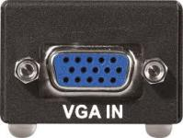
Laptop Digital Display to VGA Adapter Types
Full-size HDMI | This is the full-size HDMI connector, like you would see on a HD television. These are common on PC laptops and are also available on the Retina MacBook Pros. | 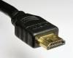 | 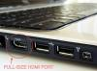
Mini HDMI | This is a smaller version of the HDMI connector and is common on PC laptops. | 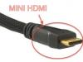 | 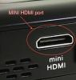
Micro HDMI | This is the smallest HDMI connector, and is mostly seen on tablets and cameras. | 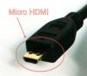 | 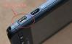
Displayport | This is the full-size Displayport adapter, which is very rare. | 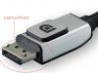 | 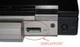
Mini-Displayport/  Thunderbolt Port | All Macbook Pro and Air laptops from mid-2008 to the present and the white Macbook laptop starting in Fall of 2009 have this connector. 2011 models are labeled as Thunderbolt ports but the connector is the same. | 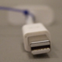 | 