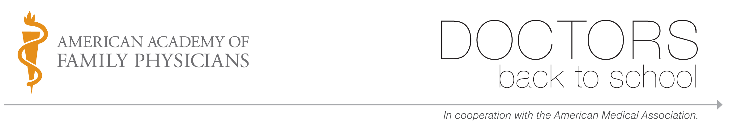

Sample thank you letter:

Oct. 1, 2008
Jane Smith, Principal
ABC Elementary School
123 Main Street
Anyville, US 00000

Dear Ms. Smith,

Thank you for hosting my Doctors Back to School visit on Sept. 9. The students and I had a great time together. It was an incredibly rewarding experience.

Increasing minority representation in medicine will be necessary to ensure the best, most appropriate care for our increasingly diverse population. Your participation in Doctors Back to School has played an important role in raising awareness of the need for more minority physicians and sowing the seeds of interest for the next generation of potential doctors. I hope to welcome one of your students as a colleague someday. Many thanks for your warm welcome and cooperation.

Sincerely,

Mary Brown, MD
Physician, Memorial Hospital

