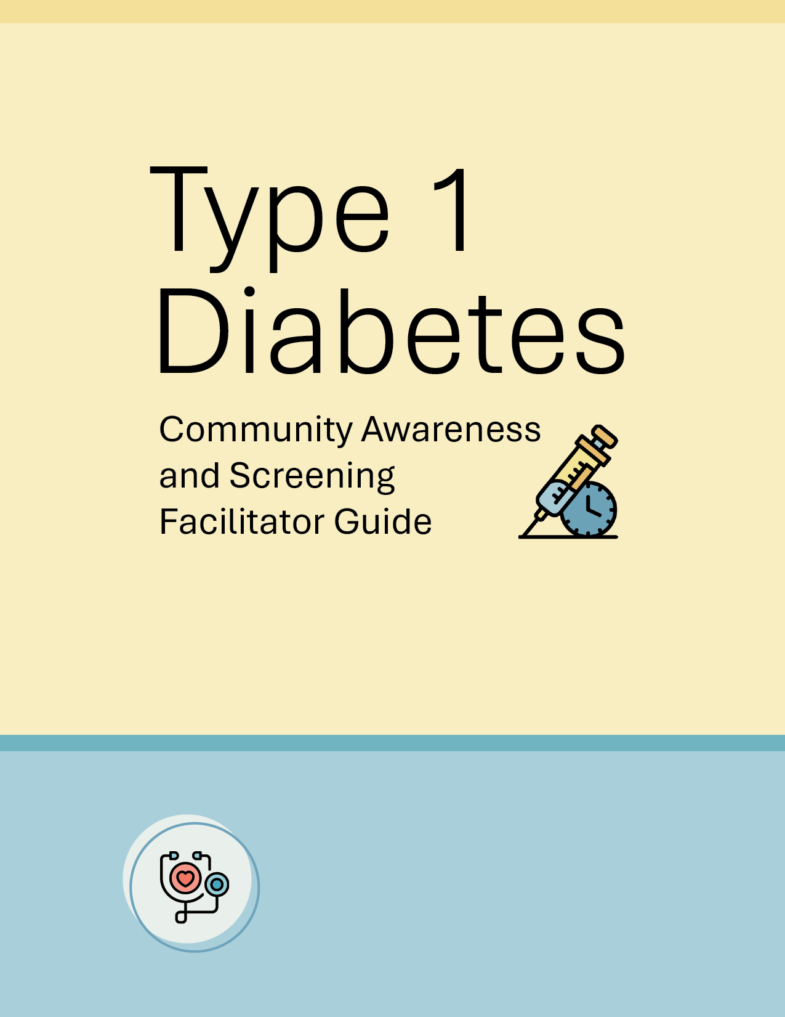

Hosted by:
Dr. [Family Physician's Name]
10.13.25 | Leawood, Kansas

Table of Contents

- Introduction
- Event Planning & Recruitment
• Recruitment Strategy
• Presentation Guidance
• Community Engagement Tips
- Slide-by-Slide Talking Points & Engagement Tips
- Appendices
• Attendee Handout
• Family Doctor Handouts
• Screening Location Handout
• Awareness Campaign Materials

1. Introduction
This guide is designed to help facilitators lead community awareness sessions on type 1 diabetes (T1D) and the importance of early screening. It includes planning tips, talking points, and engagement strategies tailored for diverse audiences.

2. Event Planning and Recruitment
Effective event planning is essential for a successful type 1 diabetes (T1D) awareness session. Facilitators should utilize an accessible venue equipped with necessary AV tools, seating arrangements that accommodate all attendees (including those with disabilities), the slide deck, printed handouts, sign-in sheets, and screening referral forms. Outreach resources such as flyers, social media templates, and email invitations should be ready to be distributed. Facilitators can engage local leaders, educators, and health workers to co-host or promote the event by leveraging these materials within their networks.
Recruitment Strategy
Recruitment efforts should be customized for each community setting. The 'Swiss Cheese' communication resources have been specifically created for facilitators to adapt and tailor messaging across platforms—such as social media, local radio, school newsletters, and community bulletin boards—to best reach their audience. Collaborate with school districts, tribal councils, YMCA program directors, and clinic outreach coordinators to distribute these adaptable materials. Messaging should highlight the importance of early screening and awareness, using suggested phrases like 'Early screening saves lives—know the signs of type 1 diabetes' and 'Join us for a free community workshop on diabetes awareness.'
Presentation Guidance
Facilitators should review the provided slide deck and use the talking points and audience engagement ideas included in this guide. To enhance participation, incorporate local stories, testimonials, and culturally relevant visuals. Encourage questions and interactive discussion to create a participatory environment. Use the recommended statistics and examples that reflect the specific audience—whether in schools, clinics, tribal communities, or YMCAs. Remember to manage time effectively by following the suggested timing for each section to ensure the session stays on track.
Community Engagement Tips
Building community partnerships enhances the impact of the education session. Reach out to stakeholders in your community such as local health organizations, tribal health centers, and YMCA leadership. Use culturally relevant materials, including translations and diverse imagery, to ensure inclusivity. Leverage digital tools like community apps and peer support networks to maintain engagement post-event. Encourage facilitators to stay connected with attendees and provide updates on screening opportunities and resources.

3. Slide-by-Slide Talking Points and Engagement Tips

Slide 1: Understanding Type 1 Diabetes
Talking Points:
- Hello everyone! I’m Dr. [Name], and today we’re going to talk about type 1 diabetes—what it is, how to spot it, and why screening is important.

Slide 2: Welcome and Overview
Talking Points:
- Thank you for coming! We’re here to learn about type 1 diabetes and how catching it early can help people stay healthy.
- We’ll talk about what type 1 diabetes is, what signs to look for, who’s at risk, how screening works, and hear some real-life stories.
- Whether you're a parent, caregiver, or healthcare professional, this session is for you.
Idea Prompt for Presenter:
- Mention any local events or programs related to diabetes awareness.
Audience Engagement Tip:
- Invite attendees to share what they hope to learn today.

Slide 3: Understanding the Disease
Talking Points:
- Type 1 diabetes is an autoimmune disease. That means the body’s immune system attacks the cells that make insulin.
- Insulin is an important hormone that helps our bodies use sugar for energy.
- Unlike type 2 diabetes, type 1 isn’t caused by eating too much sugar or not exercising—it can happen to anyone, at any age, and it does not go away.
Idea Prompt for Presenter:
- Use a simple diagram or analogy to explain how insulin works.
Audience Engagement Tip:
- Ask if anyone knows someone with type 1 diabetes and what they’ve seen or experienced.

Slide 4: Recognizing the Symptoms
Talking Points:
- Some signs of type 1 diabetes are peeing a lot, feeling very thirsty, losing weight without trying, feeling tired, and having blurry vision.
- These symptoms can show up quickly. If you notice them, it’s important to see a doctor right away to avoid serious problems.
Audience Engagement Tip:
- Ask the audience to guess some symptoms before revealing them.

Slide 5: Who is at Risk?
Talking Points:
- Some people have a higher chance of getting type 1 diabetes because of their genes or things in their environment, like certain viruses.
- But most kids or adults who end up with type 1 diabetes don’t have anyone in their family who has been diagnosed with it.
- That’s why it’s important for everyone to know the signs and think about screening.

Slide 6: Why Early Screening Matters
Talking Points:
- Finding type 1 diabetes early can help prevent dangerous problems and lets doctors start treatment sooner.
- Sometimes, early treatment can even delay diabetes from getting worse for a couple of years.
- That gives families more time to get ready and learn how to manage it.

Slide 7: Screening Guidelines
Talking Points:
- Right now, there aren’t national rules for screening everyone for type 1 diabetes.
- The American Diabetes Association says people with a family history or certain genes should get screened.
- But anyone with symptoms should see a doctor for testing.
- There are programs, like TrialNet, that offer free testing for people who qualify.
Idea Prompt for Presenter:
- Bring printed handouts or show a website where people can learn more:
  - Early-Detection-Screening-Guidance-Tool-EN.pdf
Audience Engagement Tip:
- Walk through how to sign up for a screening program together.

Slide 8: How is Type 1 Diagnosed?
Talking Points:
- Your age, risk factors, and other criteria determine which screening options you’re eligible for.
- Doctors use blood tests to check for diabetes.
- Some tests look for sugar levels while others look for special markers called autoantibodies.
- These markers can show if someone is at risk, even before they have symptoms.
- A positive test doesn’t mean you’ll get diabetes, but it’s a sign to watch closely.
Idea Prompt for Presenter:
- Show a sample test kit or diagram of how the test works.
Audience Engagement Tip:
- Ask if anyone has had a similar test before and what it was like.
- Help participants scan QR code to learn more about early detection from Breakthrough T1D

Slide 9: Treatment & Lifestyle
Talking Points:
- People with type 1 diabetes need insulin every day. They might use pumps, pens, or shots.
- It’s also important to check blood sugar often, eat healthy foods, exercise, and take care of mental health.
- New treatments, like immunotherapy, are being studied and may help slow down diabetes in the future.
Idea Prompt for Presenter:
- Bring in a guest speaker who uses one of these treatments.
Audience Engagement Tip:
- Ask the audience what they think is the hardest part of managing diabetes.

Slide 10: Daily Life & Support
Talking Points:
- Living with type 1 diabetes means planning meals, taking insulin, and staying active.
- Support from family, friends, and school or work is very important.
- Talking to others and joining support groups can help people feel less alone.
- Breakthrough T1D has a consortium of resource guides for T1D – Resource Guides

Slide 11: Real Voices
Talking Points:
- Let’s hear from real people—a teen who found out early through screening, and a parent who helps their child manage diabetes.
- Their stories show how early detection and support make a big difference.
Idea Prompt for Presenter:
- Invite a local family to share their story live or via video, or utilize these early detection testimonials from Breakthrough T1D
  - Early-Detection-Screening-Guidance-Tool-EN.pdf
Audience Engagement Tip:
Ask the audience what part of the story stood out to them.

Slide 12: Your Questions Answered
Talking Points:
- Now it’s your turn! Please ask any questions or share your experiences.
- There are no silly questions—everyone is here to learn and help each other.

Slide 13: Key Takeaways
Talking Points:
- Type 1 diabetes is a serious condition; however, early detection can be lifesaving. Due to advances in medical research, early identification of T1D not only provides an opportunity for proactive planning but may also allow for the delay of symptom onset.
- Screening is simple and more available than ever.
- Support and good management help people live well.
- You can find more help at BreakthroughT1D.org, TrialNet.org, or your local clinic.
- Share what you learned today—it could help someone you know.

Slide 15: Thank You for Joining
Talking Points:
Thank you for being here! If you have more questions, you can contact me at [email] or [phone].
We have handouts and resources for you. Let’s keep learning and supporting each other.

4. Appendices
Facilitators should familiarize themselves with the supplemental materials provided in the toolkit. These include printable handouts and fact sheets that summarize key information about type 1 diabetes, its symptoms, and the importance of early screening. A directory of local screening sites is included to help guide participants to appropriate services. Outreach templates—such as sample emails, flyers, and social media posts—can be customized for each audience. Finally, evaluation forms and feedback templates are provided to streamline post-event reporting and continuous improvement.
  - Attendee Handout
  - Family Doctor Handouts
  - Screening Location Handout
  - Awareness Campaign Materials

