AAFP Credit System

Audit Report

Upon completion, please upload this document, along with all other requested documents, to the audit dashboard link that was provided to you via email.

Purpose
The AAFP Credit System has selected your CME activity for an audit. The audit checklist outlines all the information that the CME provider organization must provide for the audit to be conducted. The information from the checklist should be provided within this report to streamline the audit review process for both the CME provider and Credit System staff.
Once the information has been added to this report, please upload it through the audit dashboard link that was provided in the audit submission email. The link is also accessible through your CME Provider Dashboard portal under the Approved tab. The only things that should be uploaded separately from the report are slides, or PowerPoint presentations.
For more information on the overall audit process, please visit our website. For more information on what’s required for the COI portion of the audit, please watch this webcast.

Deadline
You have four weeks to complete this Audit Report and upload it into the audit dashboard link, along with the applicable slide.

Completing the Report
This report requires electronic input. Each numbered item contains a field for you to insert text, dates, images, documents or to select from a menu of options.
To insert images into the document select Insert, Object, Create from File (browse for the appropriate file) and select “Display as an icon”. You can enter more than one document/image into a text box.
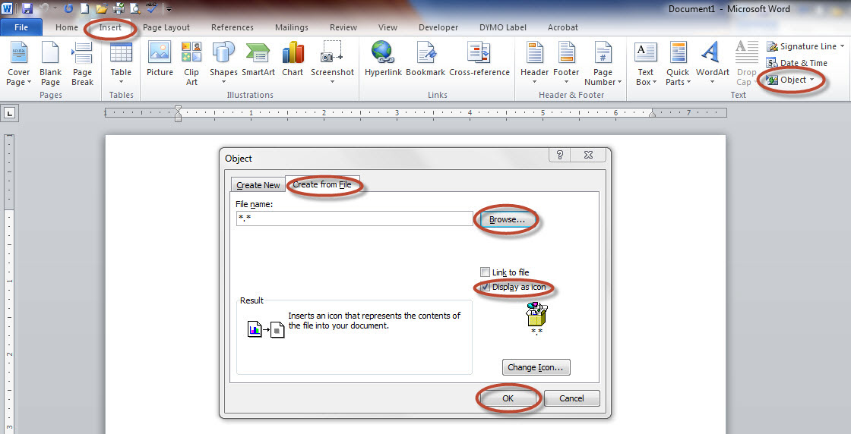
At the end of most questions the criteria that the question is intended to answer is listed in parentheses. These criteria have been hyperlinked to the appropriate source document or website for your reference.

General Activity Information
1. | Application Number: | Click here to enter text.
2. | Title of the Activity: | Click here to enter text.
3. | Activity Start Date: | Click here to enter a date.
4. | Activity End Date: | Click here to enter a date.
5. | If this activity was developed in collaboration with another organization, please provide a description of the collaboration including division of roles and responsibilities and upload any letters of agreement between the organizations. If your activity was not developed in collaboration with another organization, please skip thisquestion.
6. | Insert a copy of all CME activity marketing materials such as the agenda, brochure, syllabus, and handouts.
7. | If this was a Performance Improvement or Point-of-Care activity, or included Translation to Practice® (t2p™), please include documentation of how learners engaged in each of the required steps. If your content is not a PICME, Point-of-Care, or didn’t implement t2p™, please skip this question.
8. | Insert the AAFP credit statement, as printed in the activity materials and published on any websites, etc.
9. | Insert the AAFP CME seal as printed in the activity materials and published on any websites, if applicable.
10. | Insert activity planning documentation, including how the following were identified/defined: professional practice gaps, needs assessment, core competencies, learning objectives and learner engagement.
11. | Insert completed activity and learner evaluations.

Educational Content
12. | Please upload a copy of each slide deck, or PowerPoint presentation, journal article, etc. from the CME activity into the audit dashboard that can be accessed through the CME Provider Dashboard portal under the Approved tab. DO NOT attach slide decks to this document due to size limitations. Please attach in the audit dashboard as outlined above.  Please title the documents using this naming convention: “Title of Session/Article-Faculty Name(s).”
 |  | a. | If the educational content is only accessible through an online website, then please provide login credentials below along with a list of all of the articles/sessions that are included within the online educational content. If your content is not online, please skip this section.
Username: | Click here to enter text.
Password: | Click here to enter text.

List of Online Educational Content (“Title of Session/Article – Faculty Name(s)):

ACCME Standards for Commercial Support
13. |  | Describe the faculty selection process.
14. |  | Complete the content controller spreadsheet by listing all of the content controllers involved in this CME activity.
15. |  | Insert a copy of the CME provider organization’s CME conflict of interest (COI) policy and a blank copy of the COI form(s) that were used to identify relevant financial relationships for anyone in a position to control the content of this activity. (Standard 2.1)
16. |  | If any relevant financial relationships were identified, please, insert evidence of mitigation and resolution for the identified COIs (e.g. copy of a peer review form, etc.). (Standard 2.3)
17. |  | Insert evidence that COI disclosures were made to learners prior to the beginning of the activity. (Standard 6)
 | a. |  | If verbal disclosure(s) were used in lieu of printed/published disclosures, please provide the documentation outlined here to demonstrate evidence that conflict of interest disclosures (disclosure of relevant (or no) financial relationships) were made to learners prior to the beginning of the activity. (Standard 6)

18. | Was this activity commercially supported (financial and/or in-kind)? If no, skip questions 19-23. | ☐Yes ☐No
19. | Insert letter(s) of agreement (LOA) with all commercial supporter(s) of this CME.(Standard 3)
20. | Insert the disclosure of commercial support to learners. (Standard 6)
21. | Insert a copy of the policy and procedures governing honorarium and reimbursement of out-of-pocket expenses for content controllers. (Standard 3)
22. | Insert a receipt of expenditure of the commercial support. (Standard 3)
23. | If a social event was held in conjunction with this CME activity, please insert a copy of the description/invitation or other method used to notify participants of the event. (Standard 3)

