BLSO® PROVIDER COURSE
Basic Life Support in Obstetrics (BLSO) is a course that has been adapted from the Advanced Life Support in Obstetrics (ALSO) program.
BLSO is an educational simulation program that is designed to meet the unique needs of first responders when encountered with a variety of obstetrical emergencies. The target audience might include emergency physicians and nurses, flight nurses, physician assistants, paramedics, EMT’s, residents, medical students and nursing students.
Learners are equipped with basic skills needed for both managing an uncomplicated delivery and stabilizing patients with an obstetric emergency.

OVERALL COURSE OBJECTIVES
- Improve the management of normal deliveries and obstetrical emergencies through teaching basic, standardized skills to first responders and various other healthcare workers.
- Facilitate productive, collegial interactions between all students interested in maternity care, first responders and maternity care providers.
- Assist in establishing and maintaining high standards of education and training for pre-hospital care providers; ED personnel; as well as medical, nursing, and physician assistant students.
- Promote teamwork and patient safety to improve the quality of maternity care provided by pre-hospital providers; ED personnel; and medical, nursing, and physician assistant students.

CME & CNE INFORMATION
Application for CME credit has been filed with the American Academy of Family Physicians. Determination of credit amount is pending. This course does not qualify for CNE nursing contact hours due to nursing state board regulations.

COURSE DISCLAIMER

The material presented at this course is being made available by the American Academy of Family Physicians for educational purposes only. This material is not intended to represent the only, nor necessarily the best, methods or procedures appropriate for the situations discussed, but rather is intended to present an approach, view, statement, or opinion of the instructors which may be helpful to others who face similar situations.

The AAFP disclaims any and all liability for injury, or other damages, resulting to any individual attending this course and for all claims which may arise out of the use of the techniques demonstrated therein by such individuals, whether these claims shall be asserted by a physician, or any other person.

Every effort has been made to assure the accuracy of the data presented at this course. Learners may care to check specific details, such as drug doses and contraindications, etc., in standard sources prior to clinical application. The AAFP does not certify competence upon completion of the BLSO Provider Course, nor does it intend this course to serve as a basis for requesting new or expanded privileges.

For more information on
Advanced Life Support in Obstetrics
please visit www.aafp.org/BLSO

DIRECTIONS TO COURSE SPONSOR: All elements in this template must remain in order to be in compliance` with AAFP, ACCME, and ABOG guideline requirements.
Please complete these highlighted areas in full before submitting:
- Course Date, Location, and Course Sponsor Name.
- Course Contact Information (Names of Director, Advisory Faculty, and Course Coordinator contact information)
PLEASE DELETE THIS RED BOX after all of the above steps are completed (click on box border and press ‘delete’), and remove the yellow highlights before submitting/uploading to your course’s CME application (Step 4), or before printing for your learners.


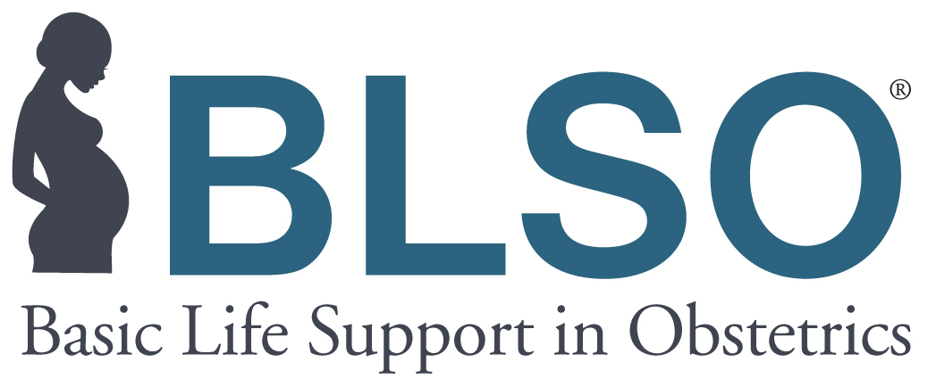

BLSO Provider Course

[Course Date]

[Course Location]

[Course Sponsor Name]

COURSE PRE-WORK
Learners will be provided an email link to the online pre-test, which must be completed prior to the start of the course.

The completed pre-test must be provided to the Course Sponsor as proof of successful completion of course pre-work PRIOR TO participation in the Live Portion of the course.

There will additionally be instructions on how to instantly download and print the BLSO Provider Manual to read/review prior to the course.

AFTER THE COURSE
After the course is complete, the Course Sponsor is responsible for providing post-course documentation to the ALSO Program within 2 weeks. After the Course Sponsor has submitted all required post-course documentation, learners will be emailed letters of participation by the AAFP. For those who successfully complete all course requirements, wallet cards will be additionally included at the bottom of the emailed letter of participation.

COURSE AGENDA

Workstation Rotations
(Learners are divided into four groups and will rotate between four workstations throughout the morning and four workstations throughout the afternoon until all workstations are completed).

Time Activity/Workstation
7:45-8:00 Registration
8:00-8:15 Welcome, Overview, Course Concepts
(15 min)
8:20-9:10 Normal Labor
(50 min)
9:15-10:05 Emergency Prenatal Assessment
(50 min)
10:10-11:00 Maternal Resuscitation and PPH
(50 min)
11:05-11:55 Breech, Twin Gestation, Cord Prolapse
and Other Malpresentations
(50 Min)

11:50-12:30 Lunch (35 min)

12:30-1:20 Shoulder Dystocia
(50 min)
1:25-2:15 Hypertensive Emergencies
(50 min)
2:20-3:10 Preterm Labor and PROM
(50 min)
3:15-4:05 Neonatal Resuscitation
(50 min)
4:10-5:10 Group Case Testing
(60 min)
5:10-5:30 Course Wrap-Up & Evaluations
(20 min)

COURSE CONTACT INFORMATION

Course Director: [Name]
Advisory Faculty: ]Name]

Course Coordinator: [Name]
Email Address: [Email]
Phone Number: [Number]






