SORT Evidence Table of Key Clinical Recommendations
We would like each article to include an Evidence Table (also called a “SORT” or “Strength of Recommendations Table”) as shown below. This table will help readers understand the main points of your article, and the strength of evidence that supports its recommendations. The table should contain the key clinical recommendations and strength of recommendation ratings for your article as shown in the sample below:
KEY CLINICAL RECOMMENDATION | STRENGTH OF RECOMMENDATION | REFERENCES | COMMENTS (OPTIONAL)
Ambulatory blood pressure monitoring is recommended for patients with labile blood pressure and suspected white coat hypertension. | B | 2 | Recommendation from consensus guideline based on observational studies
Diuretics and beta-blockers are first-line agents for hypertension. | A | 3 | Meta-analysis of randomized trials
Angiotensin receptor blockers provide similar clinical outcomes to ACE inhibitors A. | A | 4,5,6 | Consistent findings from randomized controlled trials and recommendation from evidence-based practice guideline
Terazosin is not recommended as a first or second line agent, particularly for African-American patients. | A | 7 | Randomized controlled trial
In general, you should choose approximately three to seven key recommendations for your article. Do not choose statements that merely summarize research findings or represent statements of fact; choose important clinical recommendations that reflect the best available evidence. Comments to justify your choice of references are helpful to the editors. If you are not comfortable assigning the Strength of Recommendation (below), our medical editors will do that for you.
To rate the strength of evidence supporting key clinical recommendations, please use the following guidelines:
In general, only key recommendations for readers require a grade of the Strength of Recommendation. Recommendations should be based on the highest quality evidence available. For example, Vitamin E was found in some cohort studies (Level 2 study quality) to have benefit for cardiovascular protection, but good-quality randomized trials (Level 1) have not confirmed this effect. It is therefore preferable to base clinical recommendations in a manuscript on the level 1 studies.
STRENGTH OF RECOMMENDATION | DEFINITION
A | Recommendation based on consistent and good quality patient-oriented evidence*
B | Recommendation based on inconsistent or limited quality patient-oriented evidence*
C | Recommendation based on consensus, usual practice, expert opinion, disease-oriented evidence,** and case series for studies of diagnosis, treatment, prevention, or screening
* Patient-oriented evidence measures outcomes that matter to patients: morbidity, mortality, symptom improvement, cost reduction, quality of life.
** Disease-oriented evidence measures intermediate, physiologic, or surrogate endpoints that may or may not reflect improvements in patient outcomes (i.e., blood pressure, blood chemistry, physiological function, and pathological findings).
Use the table below to determine whether a study measuring patient-oriented outcomes is of good or limited quality, and whether the results are consistent or inconsistent between studies:
Type of study
STUDY QUALITY | DIAGNOSIS | TREATMENT/PREVENTION/SCREENING | PROGNOSIS
Level 1 Good quality patient-oriented evidence | Validated clinical decision rule | SR/meta-analysis of randomized controlled trials (RCTs) with consistent findings | SR/meta-analysis of good quality cohort studies
 | Systematic Review (SR)/meta-analysis of high quality studies | High quality individual RCT + | Prospective cohort study with good follow-up
 | High quality diagnostic cohort study * | All or none study ++
Level 2 Limited quality patient-oriented evidence | Unvalidated clinical decision rule | SR/meta-analysis of lower quality clinical trials or of studies with inconsistent findings | SR/meta-analysis of lower quality cohort studies or with inconsistent results
 | SR/meta-analysis of lower quality studies or studies with inconsistent findings | Lower quality clinical trial + | Retrospective cohort study or prospective cohort study with poor follow-up
 | Lower quality diagnostic cohort study or diagnostic case-control study * | Cohort study | Case-control study
 |  | Case-control study | Case series
Level 3 Other evidence | Consensus guidelines, extrapolations from bench research, usual practice, opinion, disease-oriented evidence (intermediate or physiologic outcomes only), and case series for studies of diagnosis, treatment, prevention, or screening.
* High quality diagnostic cohort study: cohort design, adequate size, adequate spectrum of patients, blinding, and a consistent, well-defined reference standard.
+ High quality RCT: allocation concealed, blinding if possible, intention-to-treat analysis, adequate statistical power, adequate follow-up (>80%).
++ An all-or-none study is one where the treatment causes a dramatic change in outcomes, such as antibiotics for meningitis or surgery for appendicitis, which precludes study in a controlled trial.
Consistency Across Studies
Consistent | Most studies found similar or at least coherent conclusions (coherence means that differences are explainable); or
 | If high quality and up-to-date systematic reviews or meta-analyses exist; they support the recommendation.
Inconsistent | Considerable variation among study findings and lack of coherence; or
 | If high quality and up-to-date systematic reviews or meta-analyses exist, they do not find consistent evidence in favor of the recommendation.
Please use the following algorithm for rating the strength of evidence. For more information on how to apply these ratings, please see the explanatory article published in the February 1, 2004, issue of AFP. Again, if you are unsure how to apply these ratings, the medical editors will do this for you. At a minimum, though, you should create a summary table with recommendations and references for each recommendation.
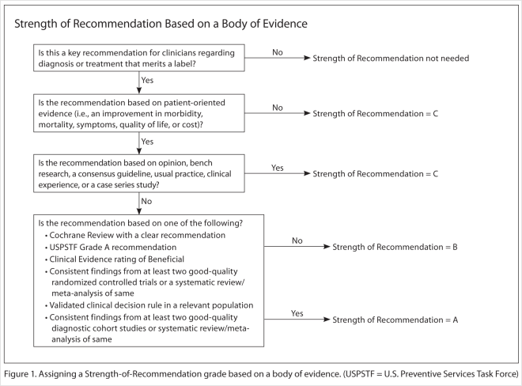
Shown above is an algorithm for determining the strength of a recommendation based on a body of evidence (applies to clinical recommendations regarding diagnosis, treatment, prevention, or screening). While this provides a general guideline, authors and editors should feel free to adjust the strength of recommendation based on the benefits, harms, and costs of the intervention being recommended.

